Assignment 1

Task A — Voltage Divider Analysis and Measurement Module

- Purpose of voltage divider: A voltage divider scales down an input voltage so it lies within the ADC input range (0–5 V) of the Arduino. It is used in the digital multimeter.
- Circuit:
Components-: Arduino UNO, Breadboard, Two resistors, Jumper wires.
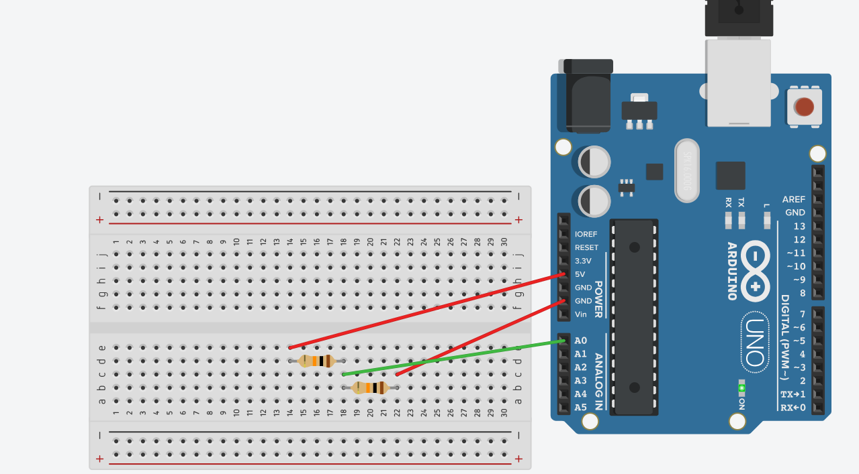
(R1=R2=10 k ohm)
- Voltage Divider Formula:
Vout=Vin(R2/R1+R2)
- ADC Reading to Voltage Conversion:
We provided Vin(Vout at R2) to A0. Arduino internal ADC converts it into a number (ranging 0 to 1023). Then our Vmeasured(Vout at R2) we calculate it by this formula: Vmeasured=adc*5.0/1023.
- Code with explanation: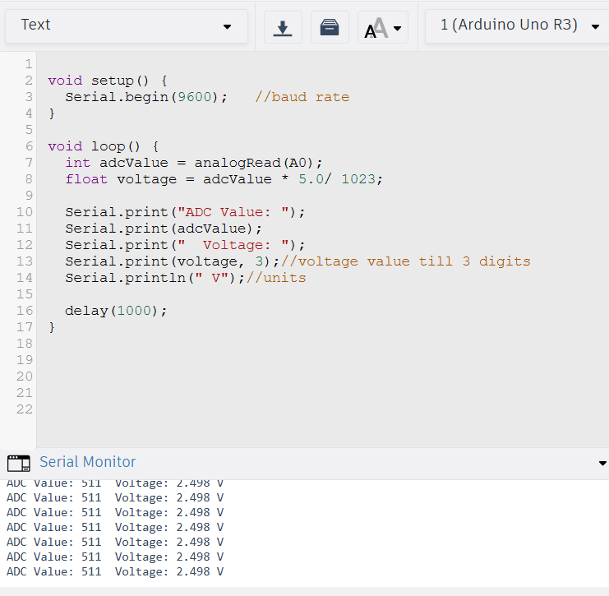
- Three cases:
Case1: (R1=R2=10kohm)
Vout=5*(10/10+10)=2.5V
ADC expected value=1023*(2.5/5)=512
Case2: (R1=4.7kohm, R2=10kohm)
Vout=5*(10/4.7+10)=3.4V
ADC expected value=1023*(3.4/5)=696
Case3: (R1=1kohm, R2=15kohm)
Vout=5*(15/1+15)=4.69V
ADC expected value=1023*(4.69/5)=959
- Serial monitor Output:
Case1: 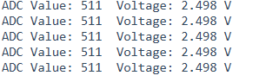
Case2: 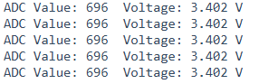
Case3: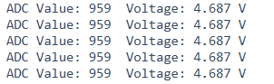
- Comparison:
Case1: Theoretical Vout (V):2.50
Tinkercad Measured (V):2.498
Case2: Theoretical Vout (V):3.40
Tinkercad Measured (V):3.402
Case3: Theoretical Vout (V):4.69
Tinkercad Measured (V):4.687
- Observations:
Small errors due to ADC quantization.
There is noise in ADC readings.
We have Limited resolution (4.88 mV per step).

Task B — Capacitance Measurement Using RC Time Constant

1. Principle: A capacitor charged through a resistor follows: Vc(t)=Vs(1-e^-(t/RC)).
At t=RC Vc=0.632Vs that is 63%.
RC is time constant. At 63% of supply voltage C=t/R.
2.Circuit: Components used:
Arduino UNO
Resistor R (here 10 kΩ)
Capacitor C (test values)
Breadboard
Jumper wires
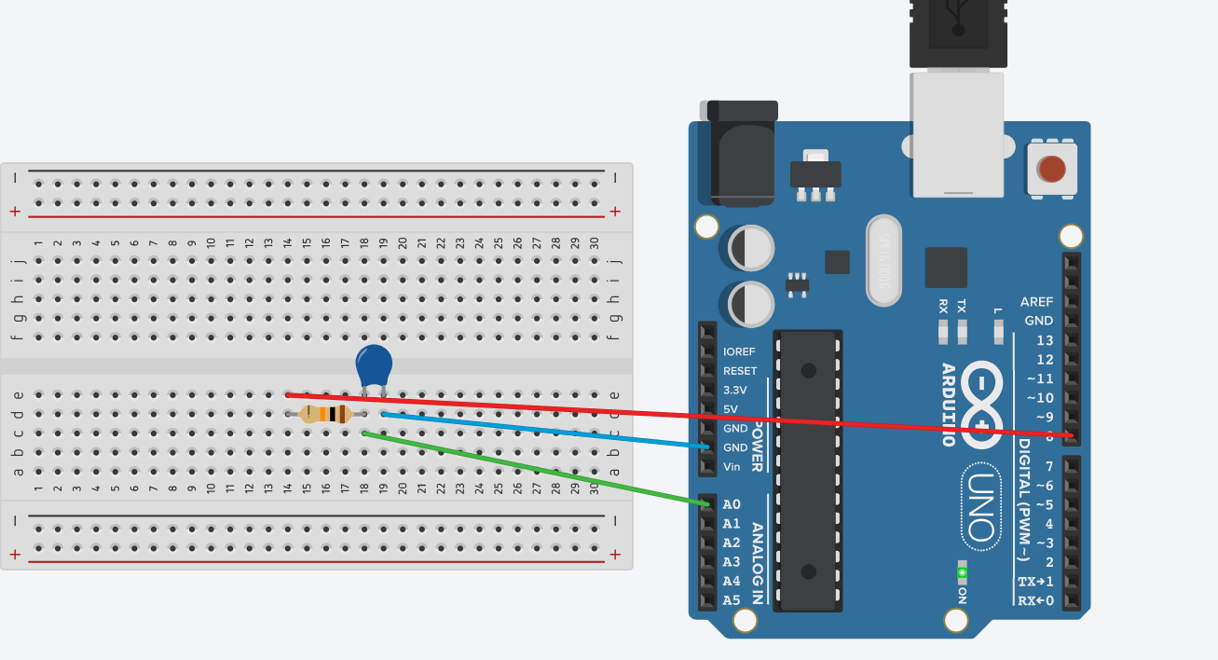
3. Why 63% is used : at t=RC Vc=0.632Vs i.e.63% and it is independent of R and C values.Also its a standard method used in instruments.
4. ADC calculation for 63% : ADC63%​=0.632×1023=647
5.Code:
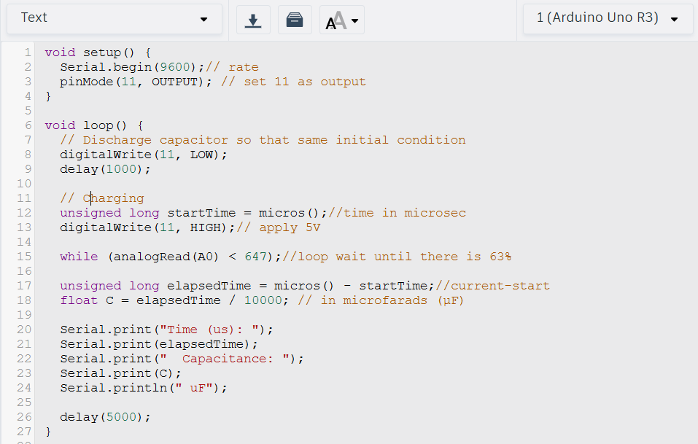
6.Test Cases:
Case1: C=10uF
t=RC=10k×10u=0.1s=100,000us
measured: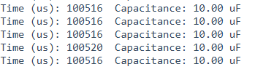
Case2: C=100uF
t=RC=10k×100u=1s=1,000,000us
measured: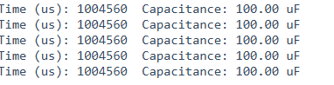

7.Observation:
Case1: C=10uF
Expected time=100,000us
Measured time=100516us
Case2: C=100uF
Expected time=1,000,000us
Measured time=1004560us
7.Error Sources:
Capacitor tolerance (+-10 to 20%)
ADC quantization error
Threshold approximation (63% that is nearly 647 ADC)
Leakage currents

Task C — Beginner Ohmmeter Prototype

1.Principle:
An ohmmeter does NOT measure resistance directly.
It measures voltage, then calculates resistance using a known resistor.
Same idea as Multimeter.
2.Circuit: Components-: Arduino UNO, Breadboard, Two resistors(one known let 10Kohm and one unknown), Jumper wires.
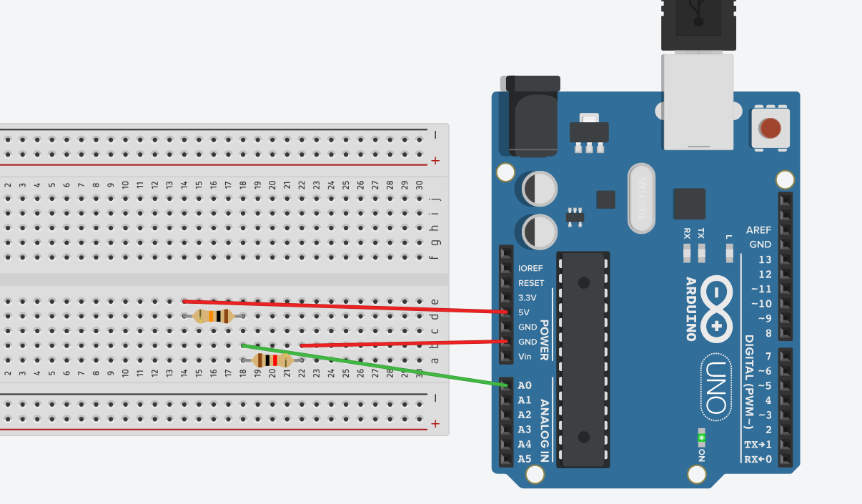
3.Working Formula:
Vout=Vin(Runknown/Runknown+Rknown)
Arduino measures Vout
Vin given that is 5V
Rknown given
Runknown calculated from rearranging eqn.
Runkown=Rknown(Vout/Vin-Vout)
4. ADC Reading to Voltage Conversion:
We provided Vin(Vout at R2) to A0. Arduino internal ADC converts it into a number (ranging 0 to 1023). Then our Vmeasured(Vout at R2) we calculate it by this formula: Vmeasured=adc*5.0/1023.
5.Code:
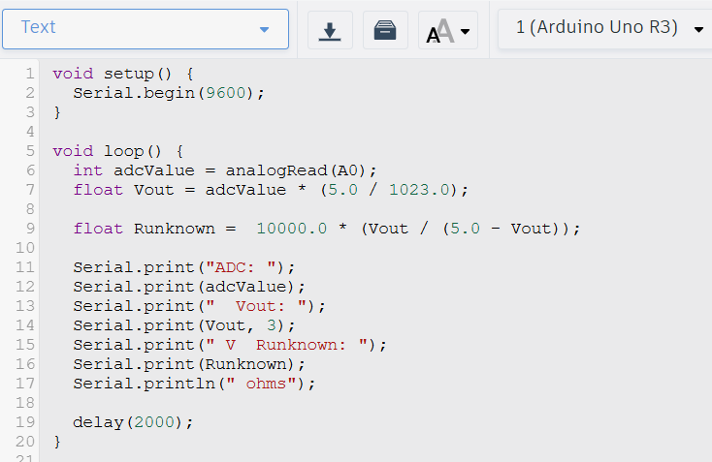
6.Comparison:
Expected value is what we placed in tinkercad(here).
Case1: Runknown=2.2kohm(expected value)
Measured Value :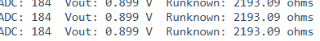
Error:0.314%
Case2: Runknown=4.9kohm(expected value)
Measured Value: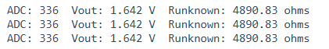
Error:0.187%
Case3: Runknown=7.4kohm(expected value)
Measured Value: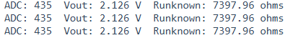
Error:0.027%
We used 1kohm to 10kohm because if R is too small then there is high current and if R is too large then there will be noise domination by ADC.
7.Measurement uncertainty:
There are various sources of error:
We have Limited resolution (4.88 mV per step).
Tolerance of Resistance.
ADC quantization error.

